AMERICAN SOCIETY OF PROFESSIONAL ESTIMATORS – OC CHAPTER 3
Presents

Strengthening & Repair of Existing Structures
Presented by Virtual Speaker, Gaetano Bologna, P.E. (gbologna@structuraltec.com) – Structural Technologies, LLC.

Date: Wednesday, March 9, 2022

Time: 4:30 PM – 5:30 PM PST

Location: Microsoft Teams meeting, Join on your computer or mobile app: Click here to join the meeting Or call in (audio only): +1 925-412-3623, ID: 585 263 910#
Gaetano Bologna is a BD Manager with Structural Technologies. In this discussion, we will walk through the complex process of strengthening existing structures that requires engineering, material science and constructability considerations. Strengthening projects may utilize conventional cement-based and steel materials as well as fiber-reinforced polymers (FRP’s). The techniques used to design and install these materials for upgrades are not as common to the construction industry which can make strengthening projects even more challenging and complex than new construction. Learning Objectives:
- Understanding factors that affect the existing structural capacity
- If strengthening is required, what options do you have?
- When to use conventional strengthening versus FRP.
- Understanding of economic considerations of these options.

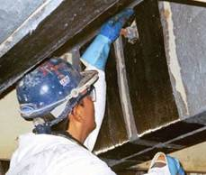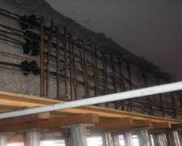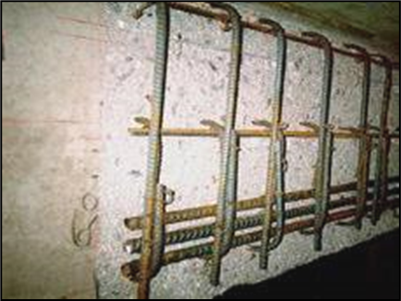

EDUCATION
ETHICS
STANDARDS
CERTIFICATION
FELLOWSHIP
PROFESSIONALISM

